**Practical 11(Database)**

**Question 1**

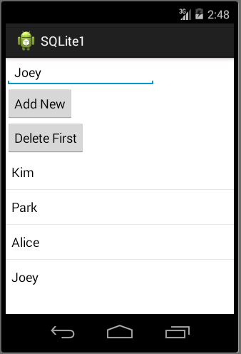

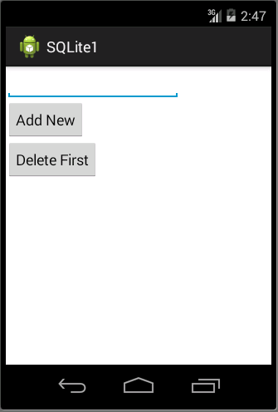

1. Your **activity_main.xml** file should have something similar to xml below: **(p/s: You do not need to follow the xml as it might be different in each design.)**

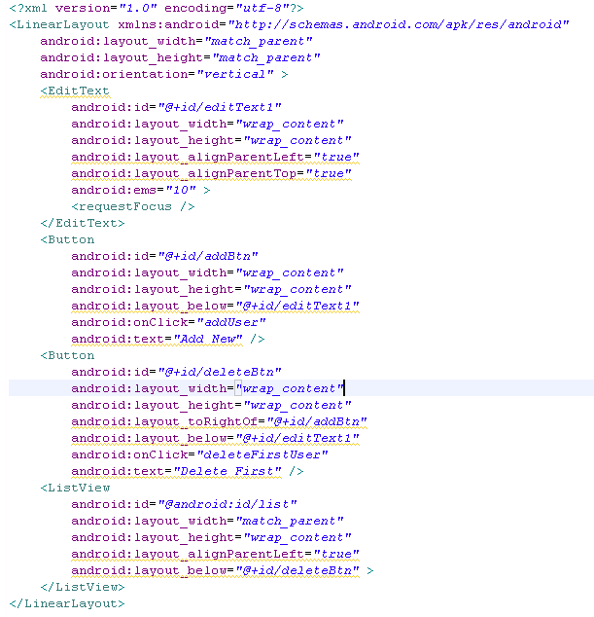



1. Create a file extend SQLiteOpenHelper as below:

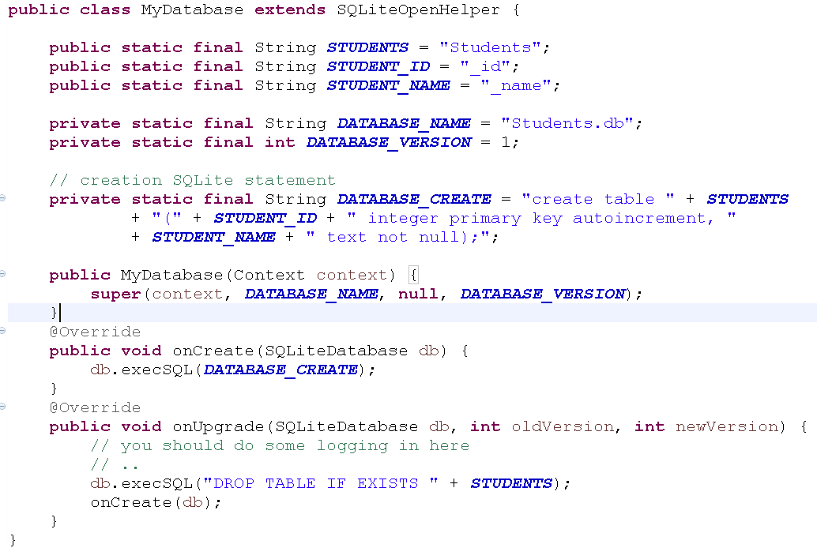

1. Create Student.java class as below:

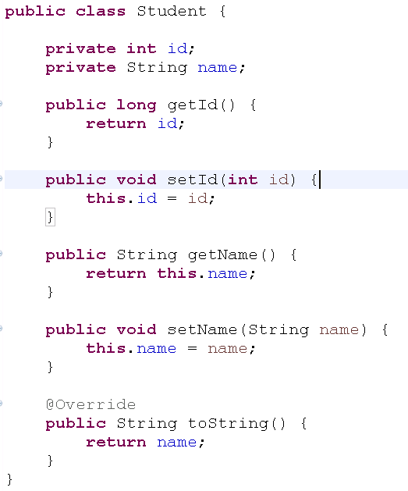

1. Create StudentOperations.java as below to create the connection between database and apps.

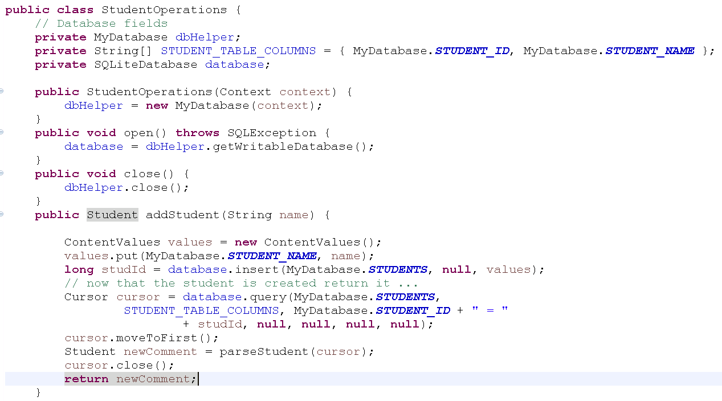

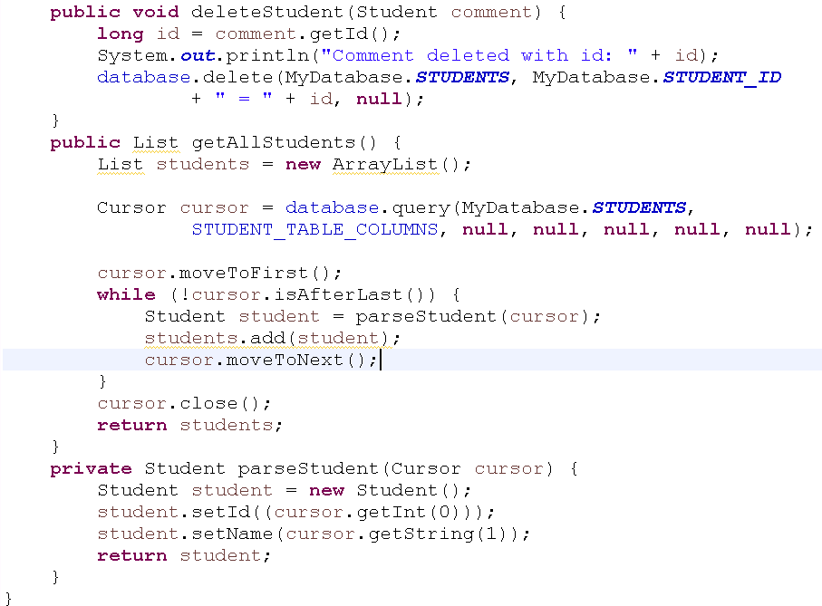

1. In your **MainActivity.java**, code the following code segment.

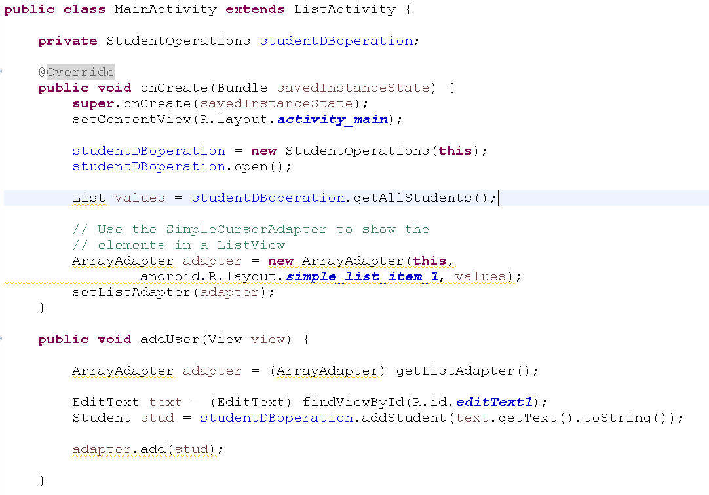

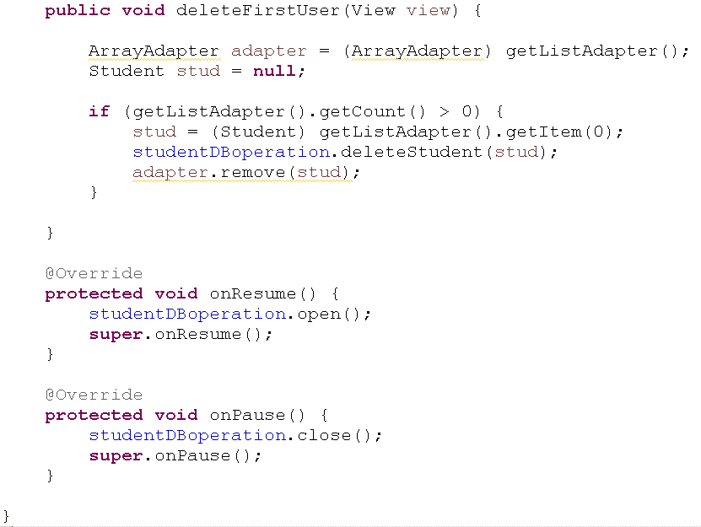

1. After make sure all the coding appropriate done, you may compile and run your coding .

**Question 2**

Based on question 1, modify the program so that you will ask the user to enter their name and also the Student ID. When a new student record is entered, you should list the Student Name and Student ID in the list view.

**Question 3**

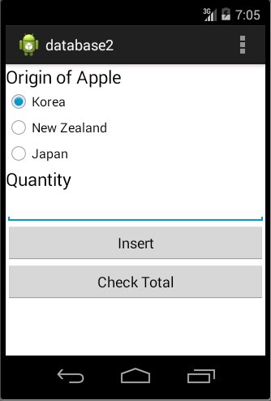

In this question, you are required to create an app with the interface as above. In this app, you should create a database to store the quantity of apple in a shop according to the origin. User can insert new apple quantity according to the selection from one of the origin and also enter the quantity.

User can click on the button check total to determine how many number of apple available in their database according to the origin of the apple.

**Question 4(Bowser history bookmark)**

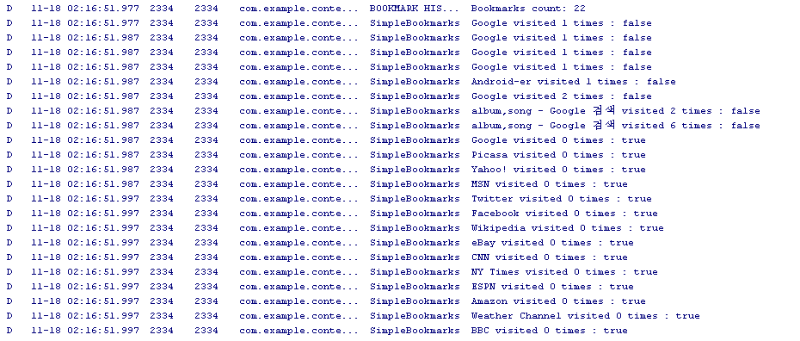

1. In this question, Layout.xml is not needed. For this, we do not need to design the layout. The running of the coding shall display on the log.
2. In your **MainActivity.java**, code the following code segment to provide function to the button created in activity_main.xml.

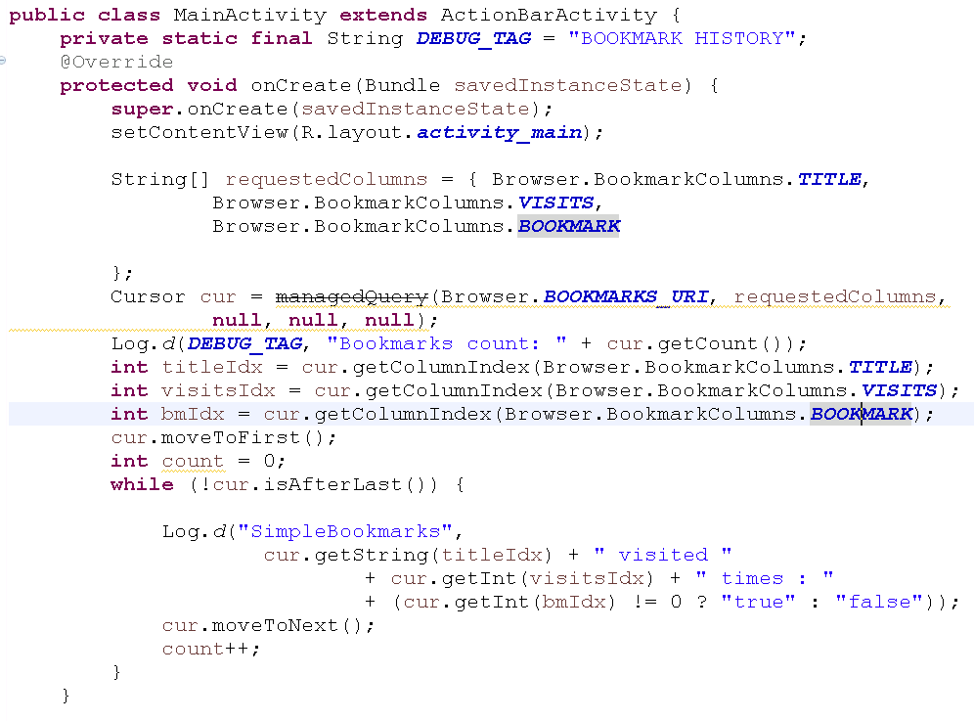

1. After make sure all the coding appropriate done, you may compile and run your coding .